**Business Problem: -** Analyse whether there are significant difference in the diameter of the cutlet between two units.

**Ho: -** There is no difference

Ha: - There is difference

Compare only 2 population

**As the data is continuous we have to check the normality test**

**Step 2:- Shapiro test**

**Ho: - Data is normal**

**Ha: - Data is not normal**

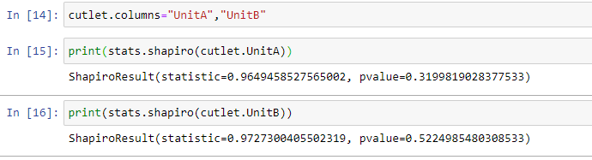

**As we can see above that the pvalue>0.05; therefore accept Ho**

**Which means both the data are normal.**

**Step 3:- The external conditions are ∴different, there go for Variance test;**

**Step 4:- Variance test**

**Ho: - Variances and equal**

**Ha:- Variances are not equal**

**LEVENE TEST**

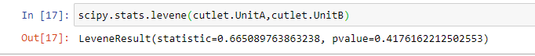

**As we can see that the pvalue > 0.05 ∴ accept Ho, i.e. :- The variances are equal.**

**Step 5:- 2 sample T for equal variance**

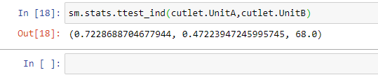

**As we can see that pvalue >0.05 ∴ accept Ho**

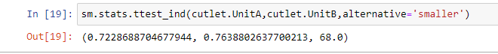

**∴ We can say that there is no difference.**

**Q.2) Business Problem: - To analyze the data and determine whether there is any difference in average TAT among the different laboratories at 5% significance level.**

Ho: - There is no difference in average TAT among the different laboratories

Ha: - There is difference in average TAT among the different laboratories.

Compare more than 2 population

Data is continuous

**Step 1: Normality Test**

**Ho:- Data is normal**

**Ha :- Data is not normal**

**# Shapiro test**

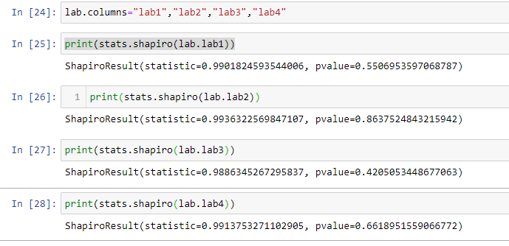

**As we can see all pvalue> 0.05 ∴ accepts Ho i.e data is normal**

**Step 2:- Variance Test (Levene Test)**

**Ho :- variances are equal**

**Ha:- Variances are not equal**

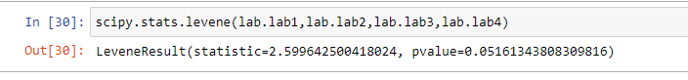

**As the pvalue> 0.05 ∴ accept Ho**

**Step 3:- One way ANOVA test**

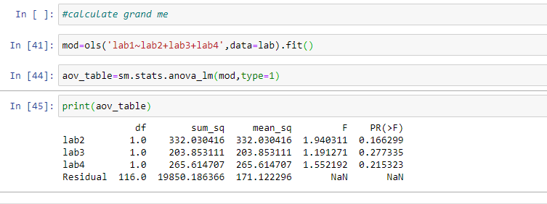

**∴ we can say There is no difference in average TAT among the different laboratories**

**Q.3)**

**Business Problem : To analyze whether All proportions are equal or not**

**Ho:- All proportions are equal**

**Ha:- All proportions are not equal**

**Data is discrete**

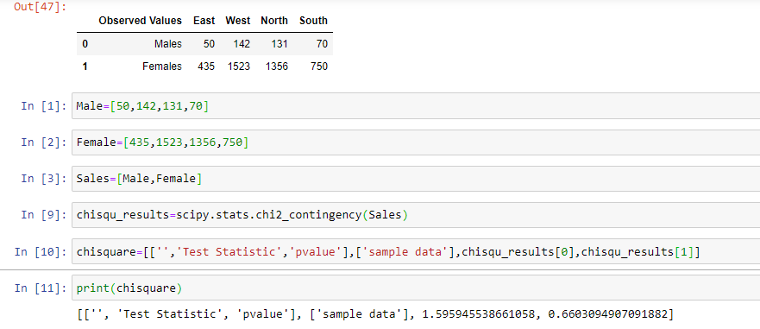

**As per the chi square test done above pvalue > 0.05 ∴ accept Ho**

**Q.4)**

**Business Problem : Analyze whether the defective % is same or not**

**Ho :- The defective % values are same.**

**Ha :- The defective values are not same**

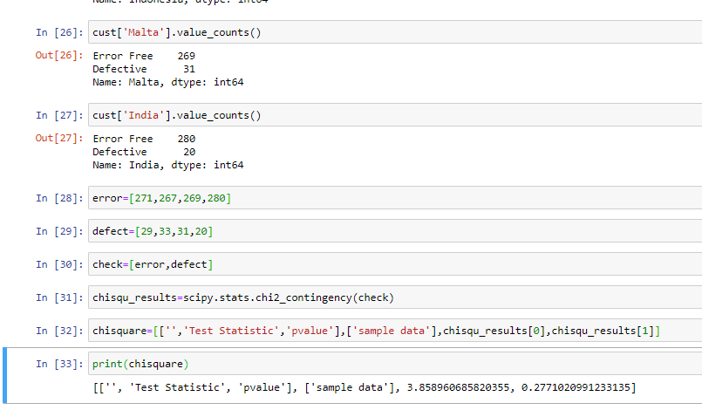

**As per the chi square test done pvalue > 0.05 ∴ accept Ho**

**Q.5) Business Problem: - To analyze whether % of male v/s female is same or different.**

**Ho: % male v/s female is same**

**Ha: % male v/s female is different**

**Since we have to compare only two population**

**# 2 proportion test**

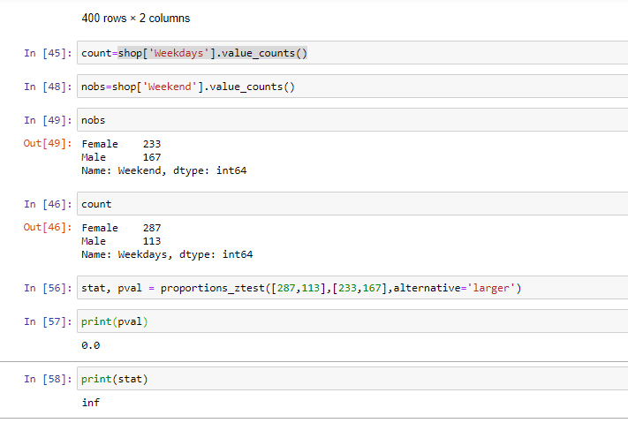

**From the above test pvalue <0.05 ∴ accept Ha**